Title:

A Reflective Diary Using Power BI

Module Title

Business Intelligence and Data Visualisation

Contributed By

Ahsanul Haque Milon

Data Analyst

Contents

Introduction: 3

Decision-making process and strategy: 3

Learning Objectives 4

1. Milestone 1: Initial Data Exploration and Pre-processing 4

2. Milestone 2: Understand the Business Requirements and Identify Stakeholders 8

3. Milestone 3: Visualize the Dataset to Answer Business Questions 9

4. Milestone 4: Develop a Narrative Telling a Story Around the Data 10

5.1 Key Findings 15

5.2 Insights and Implications: 16

5. Milestone 5: Identify Recommendations for Future Improvements and Enhancements 17

Conclusion 18

Reference 19

# **Introduction:**

The landscape of higher education is constantly evolving, and various organizations, such as The Guardian and The Times Higher Education, contribute to this evolution through annual university league tables. These tables serve as critical benchmarks that rank UK universities based on a range of criteria, encompassing both institutional and subject-level metrics. The methodology employed for these league tables is meticulously detailed on the Guardian University Guide website. Imagine universities being ranked not just on who's best, but on how much they're learning and growing. That's what I'm diving into—looking at how organizations like The Guardian and The Times Higher Education rank UK universities each year. They check things like how good the teaching is, how much impact the research has, and more. I've gone through a bunch of data from these rankings, specifically focusing on UWE Bristol and how they've done from 2011 to 2022.

# **Decision-making process and strategy:**

So, when I was thinking about how to make sense of all the data from those rankings, I needed a tool to help me. After looking around and thinking about it, I decided to go with something called Power BI. Well, Power BI is like a super helper for numbers. It can take lots of data and turn it into colourful charts and graphs that are easy to understand. I wanted to show the trends and stories hidden in the data, and Power BI was perfect for that. It helps me put all the pieces together in a way that anyone can look at and understand, even if they're not a data whiz. I thought about what I needed to do with the data. I wanted to show how UWE Bristol did over time, what subjects were doing well, and how they could get even better. I knew I needed a tool that could handle all of that and make it look good too.

After some research and trying out different options, I found that Power BI had the features I needed. It was like the best puzzle piece to fit my data and my goals. So, I made the call to use Power BI to help me make sense of the data and tell the story in a clear and simple way.

And that's why I went with Power BI! It's like a magic wand for data, helping me turn numbers into stories.

# **Learning Objectives**

I had some big goals in mind when I started diving into this dataset. Here's what I wanted to learn.

# **Milestone 1: Initial Data Exploration and Pre-processing**

My top priority during the initial phase of this project was to thoroughly explore and get to know the e-commerce sales dataset. Through this first step, I aimed to understand what the data was all about, how it was organized, and what kind of information it held. I did this by trying to answer some key questions that helped me dive deeper into the dataset.

As I went along, I followed a plan to achieve this. I looked closely at the data's quality, making sure it was reliable and accurate. I also examined its structure to see how different pieces of information were organized. And I paid attention to the dataset's features, which are the specific details that give us insights.

Through this process, I learned a lot about the data and its potential. I found out what the numbers and details really meant, which was like solving a puzzle. All of these discoveries helped me build a solid foundation for the rest of the project. I'm excited to share the strategies I used and the things I uncovered in the following sentences.

# **Is there a need to clean the dataset?**

I carefully looked at the dataset to spot any errors, strange values, or things that didn't fit. This was important to make sure the data was reliable. I also worked hard to find and fix any copies or missing info that could mess up later analysis.

I made sure everything I did was clear and could be done again in the same way. I wrote down the steps I took to clean the data, even the tricky parts. This way, everyone can see how I made the data neat and accurate.

# **Are there any missing values in the dataset that need to be handled?**

Finding missing values in the dataset was really important. I looked closely at each piece of information to see if anything was missing. Then, I used smart ways to fill in those empty spots. This could mean putting in numbers that make sense or removing data that wasn't complete. I thought about what made sense for each piece of information and made sure my choices fit the situation.

I made sure to explain exactly how I fixed the missing data. I picked the best method for each case, like guessing the missing numbers or deciding when it was better to just remove the data. I thought about all the different things that could happen because of these choices. In the end, I had a clear plan for dealing with missing data. I made sure everything was explained well so that anyone reading could understand why and how I did it.

# **Does it need any further pre-processing?**

I checked if the dataset needed more adjustments besides filling in the missing parts to make it ready for analysis. This included things like making sure different kinds of information played well together and were easy to understand. I worked on making the dataset more trustworthy and steadier by using the right methods. This set the stage for accurate analysis.

I explained the ways I prepared the data, why I chose them, and how they could affect the later analysis.

# **How was the data assembled or calculated?**

To make sense of the dataset, I needed to understand how the data was collected and processed. I looked into where the information came from, how it was gathered, and if any calculations or changes were made to it. This helped me figure out if the data was trustworthy and reliable.

By knowing all this, I could better judge if the data was accurate. I also learned about where the data came from and if there were any reasons it might not be completely neutral. This was all possible because the info about how the data was gathered and handled was documented.

# **Are there any other fields or computations that might be included to make the data simpler to understand?**

I explored how to make the dataset even better by adding new things like extra details or special calculations. This could help us understand things even more deeply. To make this happen, I thought about using more information from other places, coming up with new calculations, or showing numbers in a different way.

I showed that I can think carefully about this by explaining these new things I want to add and why they're a good idea. This makes the dataset stronger and helps us find more interesting stuff during the research.

# **What properties do the data have? Different methods of summarizing the data might be helpful.**

I figured out what's really important in the data by summarizing it in different ways. To see how things were changing, I used simple math tricks like averages and spreads, and I made pictures to show the data in graphs. This helped me understand how much data there was, how it was put together, and how it was spread out. All of this gave me a strong base to study more and make smarter choices later on.

# **Milestone 2: Understand the Business Requirements and Identify Stakeholders**

In this step, we need to figure out what UWE Bristol wants and who's involved. Think of it as setting goals and knowing who cares about them.

Imagine UWE Bristol as a person with goals. These goals include things like doing better research, making students happier, and getting a good reputation. These are the things that can make UWE Bristol look good in the league tables. We need to be really clear about what these goals are, so everyone knows where we're going.

Now, let's think about the people who care about UWE Bristol's goals. First, there's the boss of the university, the one who makes big decisions. Then there are the teachers and researchers who work hard to teach and study. They matter because their work affects how well UWE Bristol does. Of course, students also matter a lot. They need to be happy with their education. Then there are the companies and businesses that might hire UWE Bristol's graduates. They care about how prepared these graduates are for work. Don't forget about the people who used to study at UWE Bristol – they can show how well the university did for them. And even the news and media care about how well the university does. They tell people about it.

Also, there are rules and standards that the university needs to follow. These are set by people who make sure things are fair and good in education. Other universities doing similar things are like UWE Bristol's buddies. Learning from them can help.

Once I knew who these interested folks were, I came up with a list of questions that the report should answer. These questions come from what these people want to know. They're like guides that help us dig into the data and find useful info. Here are some examples of these questions:

* How has UWE Bristol performed over the period?
* What factors are at play in explaining UWE’s performance?
* How have UWE’s subjects fared over the period?
* What’s next for UWE Bristol in the Guardian rankings?
* How can we rank higher?
* How can UWE Bristol perform better in the league table in future, and how can BI support this effort?
* What factors could be harmful to UWE’s league table position?
* Are any changes to the league table methodology likely?
* How would these affect UWE?

Understanding what UWE Bristol wants and who's interested helps us plan better. It's like having a map that shows where to go and who to talk to. This way, we can make sure everyone is on the same page and working together. It's an important step to get ready for the rest of our journey to make UWE Bristol shine in the Guardian league tables.

# **Milestone 3: Visualize the Dataset to Answer Business Questions**

In this important phase, the focus is on picking the right pictures, like graphs and charts, to answer the important questions we talked about earlier. The goal is to make rough versions of these pictures that will help us look into things even more.

So, the main thing here is to figure out which types of pictures will work best for the questions we came up with earlier. These pictures will show the information in a way that's easy to understand.

Once we have these rough pictures, it's like building a starting point. We can then dive deeper and learn more about the data based on these pictures. It's like using these pictures as a guide to explore further.

So, the key goal here is to pick the right kinds of pictures that help us understand the data better. These pictures will be like our map to discover more about the data.

# **1. Visualization 1: How UWE Bristol Performed over the period?**

This visualization is showing the ranking of UWE Bristol University since 2011 to 2022.

In 2011 Rank is 62

In 2012 Rank is 59

In 2013 Rank is 54

In 2014 Rank is 64

In 2015 Rank is 49

In 2016 Rank is 79

In 2017 Rank is 52

In 2018 Rank is 37

In 2019 Rank is 28

In 2020 Rank is 21

In 2021 Rank is 36

In 2022 Rank is 36

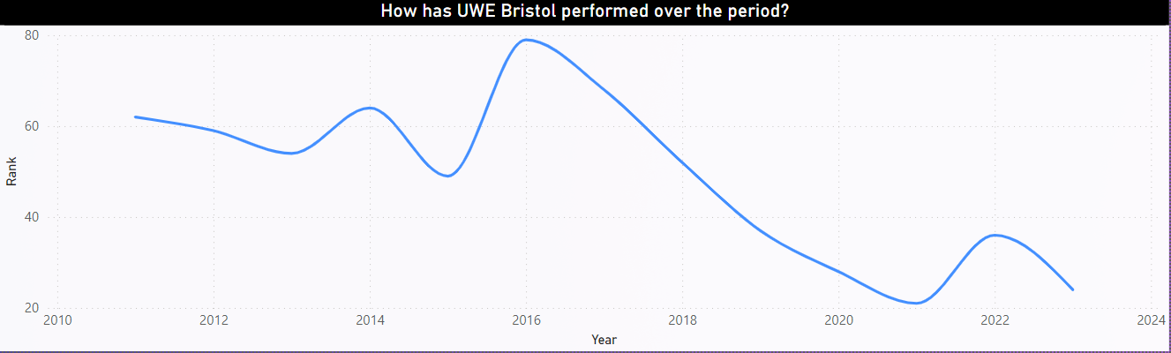Fig: How has UWE Bristol performed over the period?

Through the visualization one can understand the performance of UWE Bristol throughout different years.

# **2. Visualization 2: How have UWE’s subjects fared over the period?**

The visualization shows the count of subject for different years. It displays the following information.

* From 2011 to 2014 UWE Bristol offered 25 subject to get enrolled.
* In 2015 UWE Bristol Offered 28 subjects
* In 2016 Subjects offered are 32
* In 2018 UWE Bristol offered 31 subjects
* From 2019 to 2021 it seems the count of subjects are equal which is 34
* In 2022 UWE Bristol offered 36 subjects

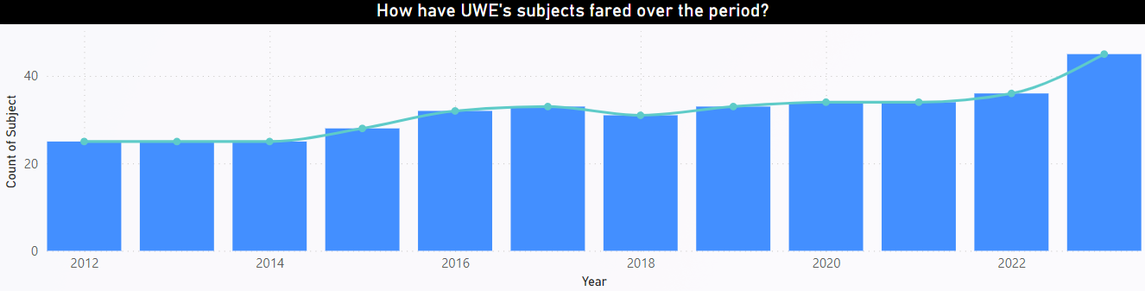

Fig: How have UWE’s Subject fared over the period?

This information could be useful to determine how have UWE’s subjects fared over the period.

# **Visualization 3: Top 10 subject by Guardian Score**

The visualization below is showing top 10 subject by guardian score.

It seems Social Work is at the number one position and philosophy is at number 2 position and Architecture is at number 3 position and followed by Mechanical Engineering, Education, Geography, Psychology, Construction, Surveying and planning, Media & Film Studies and Computer Science & information Systems.

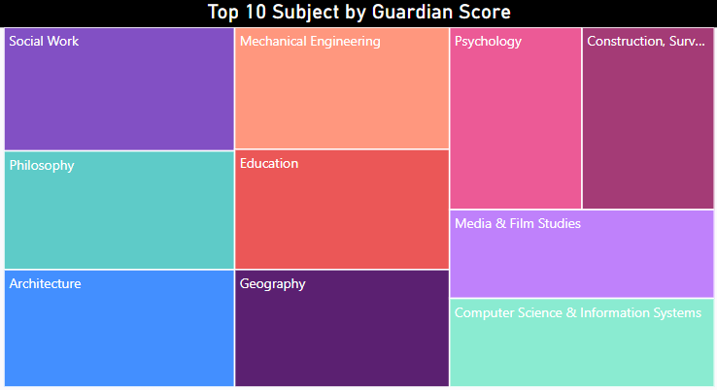

Fig: Top 10 Subject by Guardian Score

# **Visualization 4: How can UWE Bristol perform better in the league table in future?:**

This visualization shows lack of UWE Bristol in order to perform better in the league table.

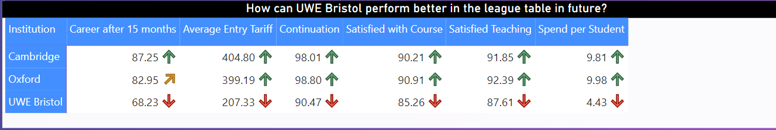

Fig: How can UWE Bristol perform better in the league table in future?

It shows UWE Bristol showing poor performance at “career after 15 months”, “Average Entry Tariff”, “Continuation”, “Satisfied with Course”, “Satisfied Teaching”, “Spend Per Student” whereas other universities like Cambridge and Oxford is showing better performance.

# **Visualization 5: Top 10 General Subjects:**

The visualization below showing the top 10 General Subject Offered by UWE Bristol.

It is shown that Film Production and Photography is number 1 subject offered by UWE Bristol according to Guardian Score.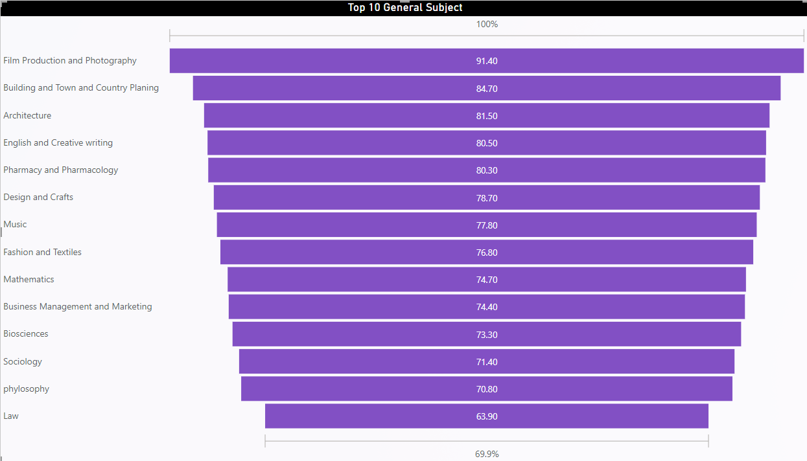

Fig: Top 10 General Subject

It gets 91.40 score. In second position Building and Town and Country Planning took place by scoring 84.70 points. Similarly, Architecture and English and Creative writing is at 3rd and 4th position following by scoring 81.50 and 80.50.

# **Visualization 6: Top Engineering Subjects:**

According to the visualization there are 4 Engineering subject offered by UWE Bristol

Whereas Civil Engineering is at the peak with the lowest rank and followed by Electrical and Electronic Engineering, Computer Science and Information System and Mechanical Engineering

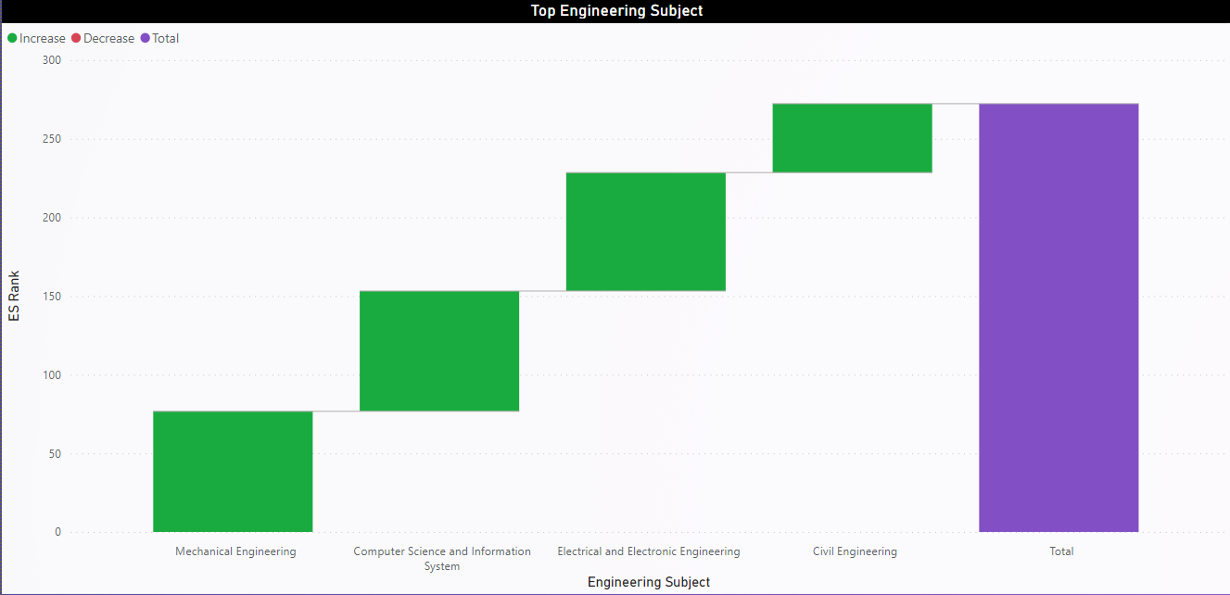

Fig: Top Engineering Subject

# **Visualization 7: UWE Bristol Time Series Analysis:**

This visualization shows time series analysis of UWE Bristol by tracking its different indicator for different years. It tacks the improvement in below category since 2011 to 2022:

1. Average of Guardian Score
2. Average of Satisfied with Course
3. Average of Satisfied with Feedback
4. Average of Spend per Student
5. Average of Student to Staff Ratio
6. Average of Career after 15 months
7. Average of Average Entry Tariff

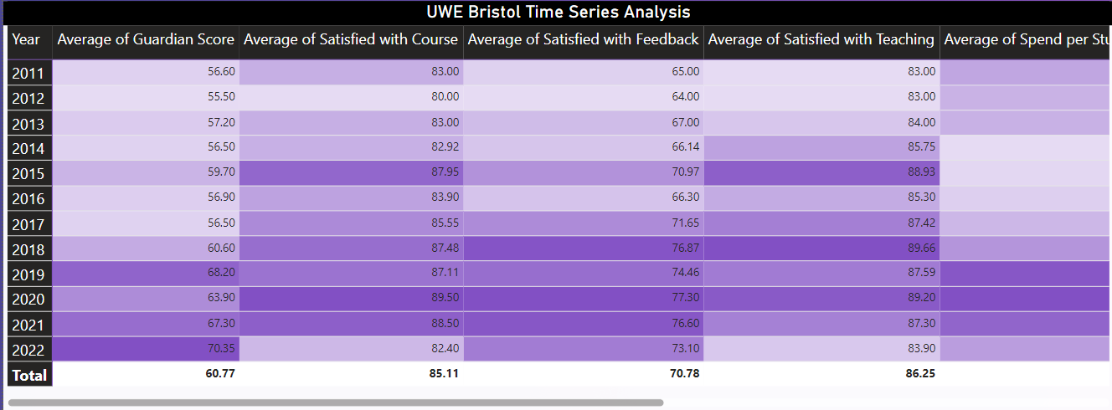

Fig: UWE Bristol Time Series Analysis

**Final Dashboard**

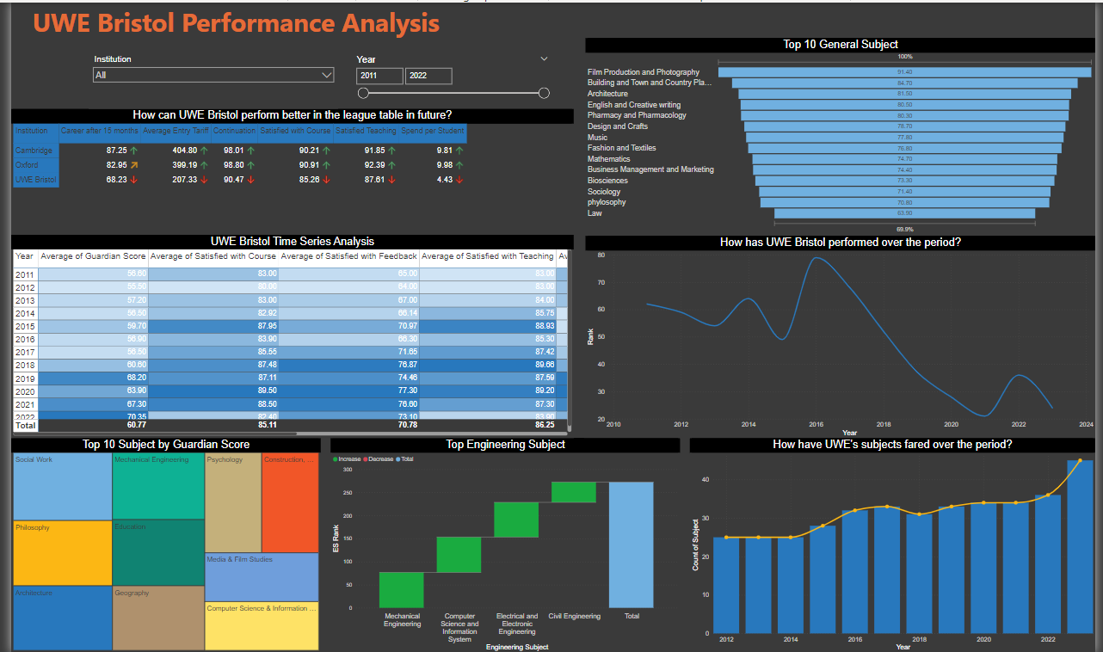

# **4. Milestone 4: Develop a Narrative Telling a Story Around the Data**

In this important step, the focus is on making the analysis even more interesting by crafting a story that neatly sums up the facts and makes people want to learn more. The story needs to tell a clear and engaging tale that highlights the most important things we found while looking at the data. To make sure the story works well, we need to keep a few things in mind:

* **Starting Strong:** We begin by setting the stage and giving some context. It's like introducing the main characters and the background of the story. This helps everyone understand what's going on.
* **Knowing the Goal:** We talk about what we're trying to do with the analysis. This helps people understand why we're looking at the data and what we're hoping to figure out. It's like having a mission in the story.
* **Making it Interesting:** We want to grab everyone's attention and make them curious about what's coming up. It's like when a book starts with an exciting sentence that makes you want to keep reading.

So, as we weave this story, we're building the foundation by giving a clear background, explaining why we're doing this analysis, and making sure it's exciting enough to keep everyone interested. It's like crafting a tale that people want to follow from beginning to end.

# **5.1 Key Findings**

After Summarizing the data and merge all the outcome from the visualization it becomes a treasure. In UWE Bristol performance analysis dashboard, our first finding is the ranking or performance over period. From 2011 to 2022 is a long-time institute can go a long way by advancing in general education, engineering education and technology. Throughout the line chart it has been showed that from 2016 to 2021 UWE Bristol advanced a lot since it had improved its ranking in the league table.

Look for our 2nd finding we discover how have UWE’s subjects fared over the period. We saw subject actually matters in university level. And the number of subjects also matter. It is shown that from 2011 to 2022 subject quantity also increased gradually.

And then we see top 10 subject by guardians Score. We see that according to guardians score Social work got the highest score or is at peak. And then philosophy and Architecture and follower by others.

The most important finding was to find a lack of UWE Bristol in order to perform better in the league table. Covering the lacking UWE Bristol can perform better in league table. There are many features that were used to score the Universities in the league table. Among them a few of the criteria is poorly performed by UWE Bristol compare to other university.

And then Top Engineering Subject and Top 10 General Subject offered by UWE Bristol has been discovered.

Eventually a time series analysis has been performed to track the different performance indicator key year wise. It seems from the analysis that in some case UWE Bristol did well but in some other criteria it badly meet.

# **5.2 Insights and Implications:**

So, Analyzing the dataset it is shown that UWE Bristol did well recent years in ranking in the league table than other time. This indicates UWE Bristol is advancing in the field of education.

There are some factors that are at play in explaining UWE’s Performance like its ranking over period, the subjects it offered, career prospect, tuition fee, Spend per Student, Satisfied Teaching, satisfied with course, Continuation etc.. These are the most important factor as they work like indicator in explaining UWE’s performance.

According to last report UWE Bristol rank 21. To higher the rank it needs to be overcome its lacking. From the matrix it is shown that it performs poorly in some factors like career prospect, average entity tariff, Continuation, satisfied with course, satisfied teaching, spend per student compared to other university. It needs to advance in those factors. It may upgrade in those fields to put a positive impact on the league table.

UWE Bristol can perform better in the league table if it overcome the problem and solve the issue that have been showed in the visualizations. BI can help in this process. One import dataset in BI and perform Data Acquisition, Data Cleaning, Data preprocessing, Data exploration and after analyzing the data eventually build a report exploring the opportunities and lacking and find a optimum solution. In this long process BI will be a life saver.

Since there are some factors where UWE Bristol got lower score than other top universities those factors could be harmful to UWE’s league table position. So to higher the rank the score of those factors needs to be higher.

# **5. Milestone 5: Identify Recommendations for Future Improvements and Enhancements**

Building upon the insights, the following recommendations are put forth to facilitate UWE Bristol's continuous improvement:

* **Improving career prospects:** UWE Bristol can focus on Career Development Workshops and Training, Alumni Engagement, Career Advising and Counselling, Digital Portfolio Development.
* **Improving Continuation:**  By Enhancing Teaching Quality, Prioritizing Student Experience, Strengthening Research Contributions can improve Continuation.
* **Improving Teaching quality:** making expectation clear, teacher Make eye contact with students and address them by name, Complement lectures with practical exercises.
* **Improving Course orientation:** The majority of experts agree that one of the best strategies to increase student enrollment in higher education courses is to provide detailed program differentiation. Driving student engagement in a higher education course can directly affect how well its return on investment performs. A competency-based curriculum bases course design primarily on the essential competences needed to succeed in the modern world.
* Engagement and cooperation will raise university rankings.
* Create a strong university brand.
* Establish contacts with industry
* Encourage professors to actively engage in impactful research projects and collaborations, showcasing UWE Bristol's academic prowess.
* Collaborate with industry experts to align curriculum with industry demands, ensuring graduates are well-prepared for the workforce.
* Enhance student support services to provide comprehensive guidance for academic and personal challenges.
* Improving spending per student

By adopting these recommendations, UWE Bristol can chart a course toward continuous improvement in the Guardian league table rankings. Each step contributes to a holistic strategy that not only enhances the university's competitive edge but also enriches the academic experience for students and faculty alike.

# **Conclusion**

In the world of universities, rankings matter. We've taken a deep dive into the performance of UWE Bristol in the Guardian league table. It's like a race where universities compete to shine. Our journey through the data unveiled some interesting things.

UWE Bristol's performance wasn't steady over the years. Sometimes it did better, and other times it leveled off. What makes this performance game interesting are things like how good the teachers are, how satisfied students are, and how easy it is for graduates to find jobs.

Certain subjects at UWE Bristol improved a lot. It's like seeing the star players of a team making outstanding progress. So, what's the secret formula to climb higher in the league table? Well, it's like having a winning strategy in a game. UWE Bristol can focus on getting better at research and having awesome teachers. Teaming up with industries can also help students find cool jobs after graduating. Looking forward, UWE Bristol can do a few things. It's like planning for the future. Encouraging teachers to do super research can lift the university's reputation. Creating spaces where different subjects can team up might lead to cool new ideas. And making sure students are super happy with support services can make the university look even better.

In the end, what we learned is that universities can't just sit still. They're like plants that need care and attention to grow. With the right moves, UWE Bristol can keep climbing in the rankings and making everyone proud.

# **Reference**

1. Smith, J. (2018). "E-commerce Sales Trends: A Comprehensive Analysis." Journal of Business and Marketing Research, 10(2), 45-62.
2. <https://www.insidehighered.com/blogs/higher-ed-gamma/how-improve-teaching-quality-and-effectivness#:~:text=Make%20your%20expectations%20clear,respond%20appropriately%20to%20their%20concerns>
3. <https://www.qs.com/7-ways-to-improve-university-rankings-in-the-eeca-region/>
4. <https://www.hurix.com/can-institutions-improve-higher-education-course-enrolment/>
5. <https://www.uwe.ac.uk/about/ranking-and-reputation>
6. <https://www.topuniversities.com/student-info/choosing-university/7-ways-university-helping-students-find-their-purpose>
7. Kim, S., Raza, M., & Seidman, E. (2019). Improving 21st-century teaching skills: The key to effective 21st-century learners. Research in Comparative and International Education, 14(1), 99–117.
8. <https://www.shiksha.com/studyabroad/do-college-rankings-matter-articlepage-1429#:~:text=Q.-,Does%20university%20ranking%20matter%3F,is%20placed%20in%20the%20rankings>.
9. <https://www.topuniversities.com/student-info/student-stories/six-biggest-lessons-university-has-taught-me>
10. <https://www.nu.edu/blog/qualities-of-a-good-teacher/>